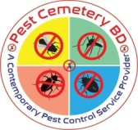

Pest Cemetery BD

Your dependable partner in Pest Control

We Eliminate & Control Pest

from the most common pests to the most intrusive type!

We will get the job done

Providing thorough, professional expertise for all your home, office and industrial pest control needs

Pest Cemetery BD

Pest Cemetery BD is a Full Stack Insects Solution Company starts to run since 2013 in Malaysia named ZR Termite. After successful business operation in Malaysia our Head of Operation Mr. Riaz Ahmed, popular Pest technician in Malaysia, decided to serve his excellence in Bangladesh. In 2018 we started our journey in our dreamland Bangladesh. We came to know that so many companies are providing pest control service in Dhaka city but none of these company using proper guideline and safety system. We decided to study more about current scenario of this industry and successfully we have done this study. Our Head of Operation Mr. Riaz Ahmed went back to Malaysia & Singapore for training and his knowledge development organized by Clark Pest Remedy, an American Pest Control Company, and he came back in 2020 with huge knowledge & experience of practical field. We decided to use American Technology along with American Chemical. We have very special care to client’s choice so that you can make your package independently. Talk to us ahead of planning insects control in your House, Office, Factory, warehouse and your business premises. We will assist you to have an insect’s free environment with our 360 degree service.

Vision:

To be the most preferred pest control company providing integrated pest management solutions to both residential, commercial and industrial properties that safeguard our environment, human health and provide peace of mind to our customers.

Mission:

To provide an environmentally friendly and effective approach to pest control services that is reliable, effective and sustainable through monitoring Techniques as outlined in our Integrated Pest Management system (IPM) and achieve overall process excellence.

Core Values:

Committed to excellence in service delivery.

Committed to sustainability of the environment and human health well- being.

To provide Innovative, effective, reliable products and services that satisfy our customer needs.

Our Organogram:

Board of Partners

Board Chairman

Managing Director

Chief Operating Officer

1. Head of Business Development
2. Head of Sales & Marketing
3. Head of Customer Care
4. Head of Research & Development
5. Head of Finance & Accounts
6. Head of Human Resource Management
7. Admin Officer
8. Board Secretary
9. Head of Operation

Supervisor

Team Leader

Team Member

Our Services:

1. Mosquito, Cockroach, Mouse-Rat, Bedbug, Fly, Termite (Batting system), Ants & Lizard control.
2. Harmful Virus/Bacteria Control of Aquarium & Swimming Pool.
3. Car Fumigation.
4. Soil Treatment

Our Integrated Pest Management Process

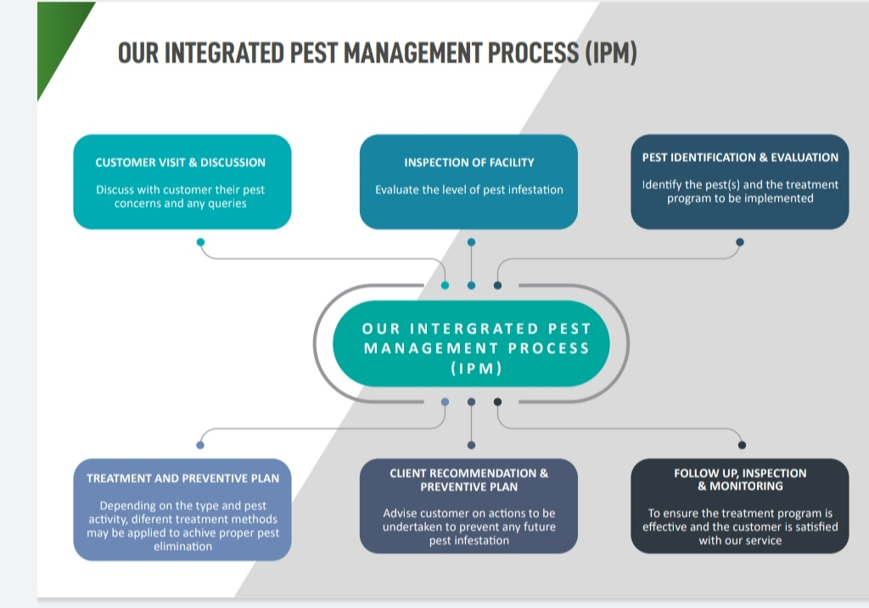

Strength

* Human Resources: have a highly trained professional team to lead the industry.



* Geographical coverage: We provide our services all over Bangladesh.



* Professionalism: We always care about our customer and we maintain standard level of professionalism while delivering, caring our services.



* Expertise: Our staffs are our passion. Our pest control training programs are widely acknowledged in the industry and all technicians are versatile in varying business environments.



* Punctuality: We believe being punctual is about being professional enough to show up at the agreed time and providing the service as offered.



* Well-equipped: Pest Cemetery BD practice the right equipment for targeting pesticides and other solutions offers better control, less waste, and the decreased likelihood of accidental poisoning

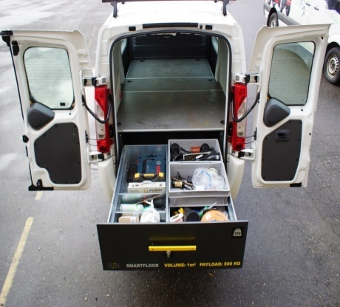

* Trained and educated staff: We arrange continuous training and knowledge development program regularly for our staff to keep them updated.

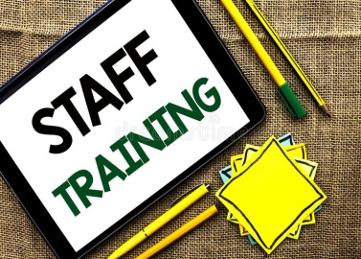

* Cost effective: Pest Cemetery BD offers very competitive price after attending proper assessment customer needs.



* Innovative solutions: Our research and development department always striving for new ideas and solutions for better customer services.

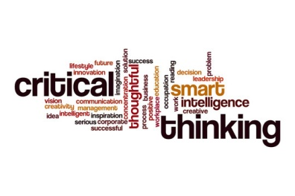

* Teamwork: We work as a team. Every member of our team has specific role to perform and our team leader confirm everyone played their role as assigned.



* Client Orientation: Pest Cemetery BD cares their clients. Our customer care department ensures that our clients are happy and take care of clients complain.



* Effectiveness: Pest Cemetery BD ensures effectiveness by Integrated Pest Management (IPM) Process.



* Efficiency: We use best technique and treatment to ensure our efficiency.



* Experience: Experience is one of our core asset. We have global and domestic work exerience.



Geographical Coverage

We cover all over Bangladesh.

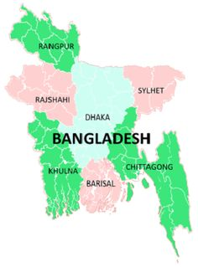

Our Journey: “ZR Termite” to “Pest Cemetery BD”

2013- Formed Partnership Business named “ZR Termite” in Malaysia.

2018- We started our business in Bangladesh & changed our name @ “Pest Cemetery BD”.

2019- Our Head of Operation Mr. Riaz Ahmed went to Malaysia for long Training course.

2020- We concentrate more on Research and Development.

2021- We started our commercial operation…………..

Clients

Our Valued Clients:

1. Al Manar Hospital Ltd.
2. Al Rafi Hospital
3. All Community Club Ltd. (ACCL)
4. A-One Polar Ltd.- Micro Fibre Group
5. Apon Foods Ltd
6. Bhulta General Hospital
7. Cleaning Care Hospital
8. Digilab Medical Services, Rampura
9. Digilab Medical Services, Mirpur-10
10. DKMC Hospital Ltd
11. Dhaka Fareast Ltd (DFL)
12. Fakir Fashion Ltd
13. Garden Gourmet By Sygmaz
14. Hi Care Hospital, Uttara
15. IBN Sina Trust, Dhanmondi
16. IBN Sina trust, Kayllanpur
17. Samorita Hospital Ltd, Panthapath
18. Sensor Printex
19. Shin-Shin Japan Hospital, Uttara
20. Simec Group, Sonim Tower, Uttara-12
21. Tanveer Food Limited (Meghna Group)
22. Meghna Group Head Office
23. Meghna Group, Dhanmondi
24. US Bangla Group
25. US Bangla Hospital
26. US Bangla Medical College
27. National Heart Foundation Hospital

Corporate Social Responsibilities:

Since the birth of our Business we are doing so many social work as corporate social responsibility. Some of our CSR mentioned below-

2013: Distribute 2 set HSC Book.

2013: Distribute Iftar among street Children.

2014: Distribute Eid Cloth among Street Children.

2014: Cash donation for a poor student.

2015: Arrange rally against Drug addiction along with “Dhanmondi Aristocrat Club”.

2016: Distribute Iftar and EidCloth among orphan student jointly with “Dhanmondi Aristocrat Club” in Narsingdi.

2017: Distribute Iftar and EidCloth among orphan student jointly with “Dhanmondi Aristocrat Club” in Gazipur.

2018: Distribute Iftar and EidCloth among orphan student jointly with “Dhanmondi Aristocrat Club” in Narayongonj.

2018: Donate 100 pcs Book to Perozpur High School, Hajigonj, Chandpur.

2019: Distribute one Auto-Ricksha and one Sewing Machine to two poor people jointly with “Green Bengal Society” in Chandpur.

2020: Arrange treatment (Leg Surgery) for 2 poor people.

2021: We arranged Oxygen Cylinder Service for Covid Patient in Chandpur District.

2022: We extended our free Oxygen Cylinder service throughout the whole year.

Certificates:

Khamarbari License

